**Answer 1)**

* Integer
* Double
* Float

**Answer 2)**

* Spelling of include is written wrong. It should be #include.
* Library name is spelled wrong <stadio.h>. The correct one is <stdio.h>.
* A format specifier “%d” is added inside the printf function which is not required since there is no integer value assigned at the moment, letter “P” of printf is written capital, terminator “;” is also missing. The correct code is: printf(“Hellow!!World!!);

**Answer 3)**

Source Code:

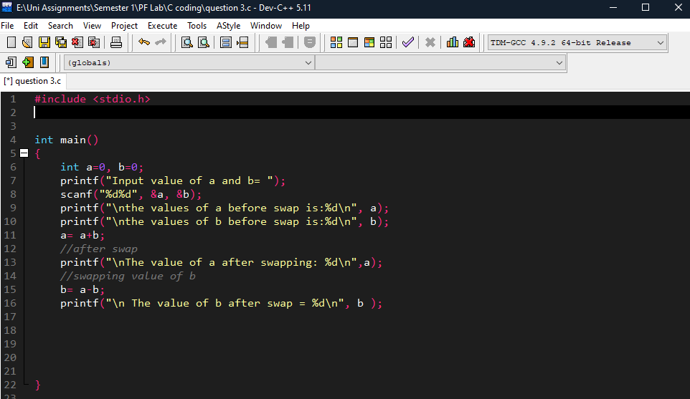

Output:

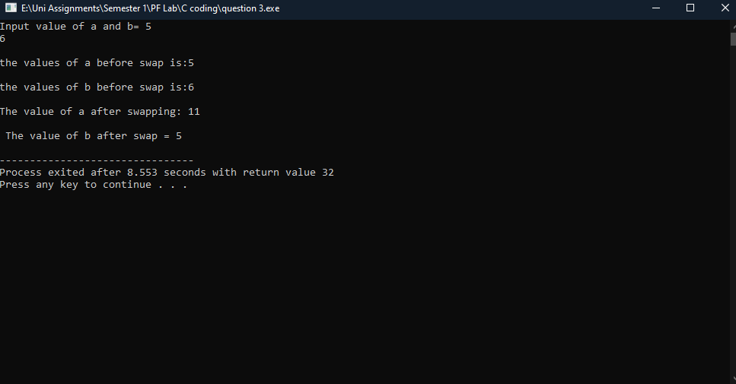

**Answer 4)**

Source Code:

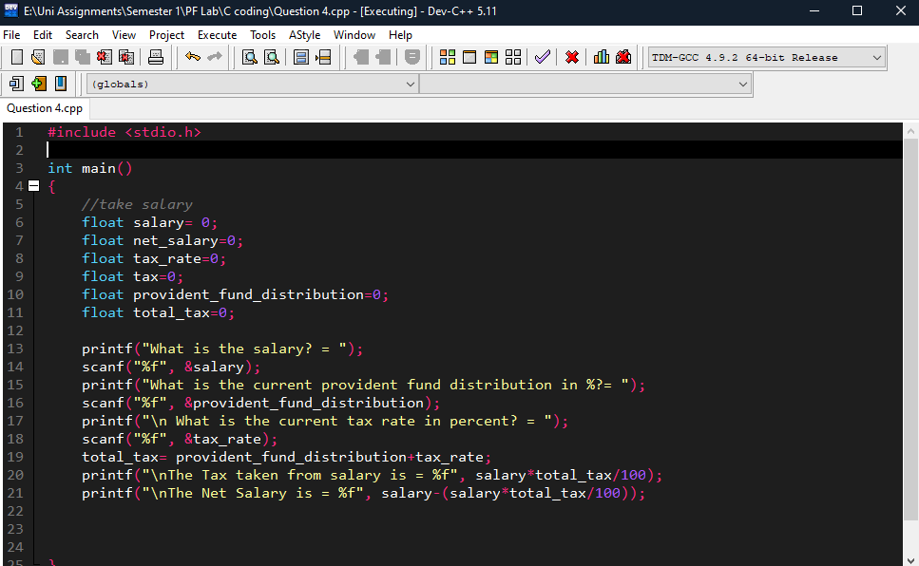

Output:

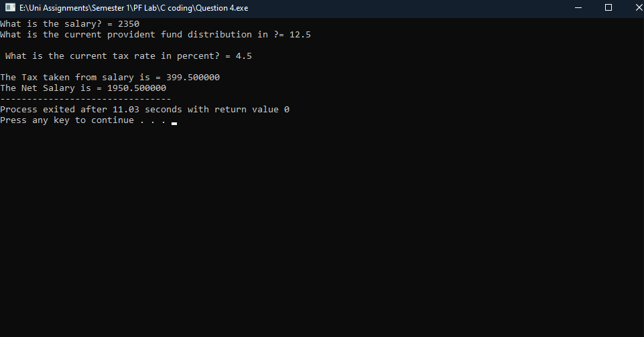

**Answer 5)**

Source Code:

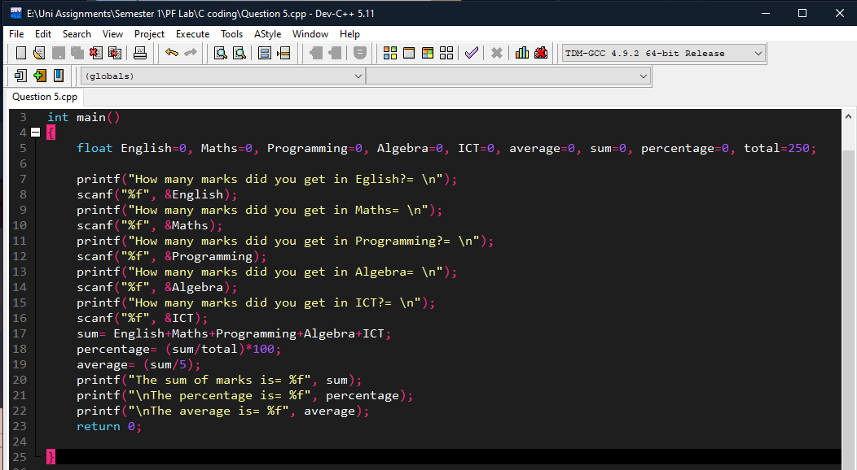

Output:

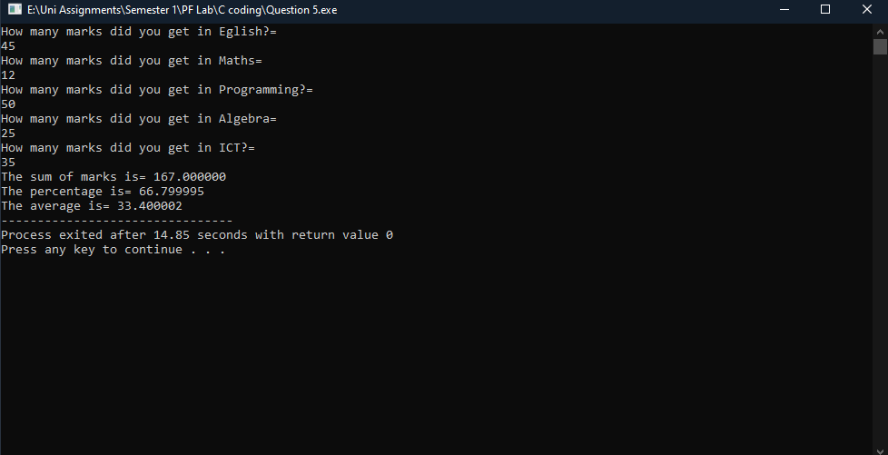

**Answer 6)**

Output:

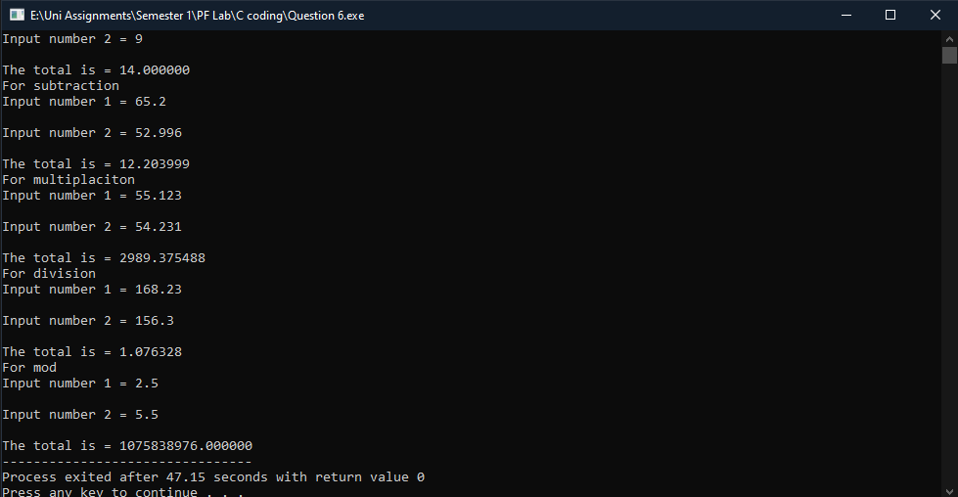

Source Code:

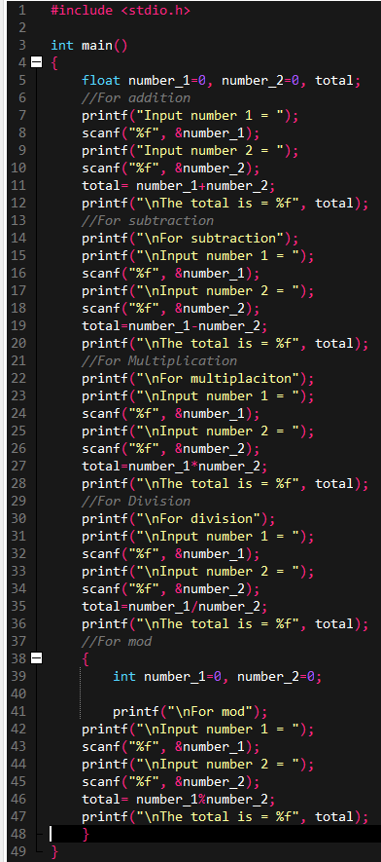

**Answer 7)**

Source Code:

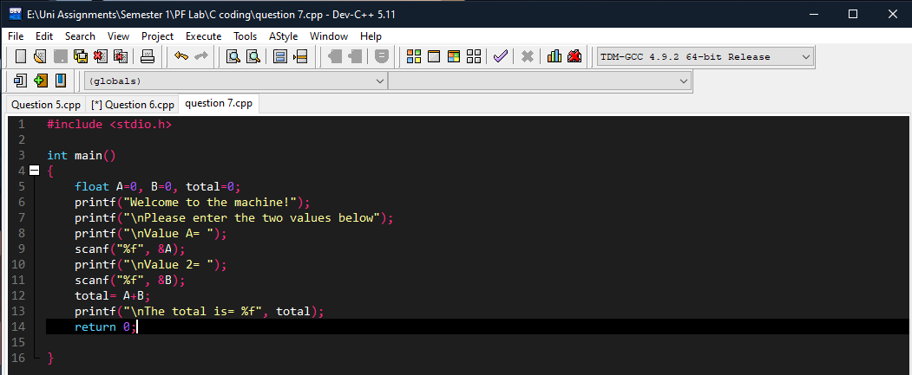

Output:

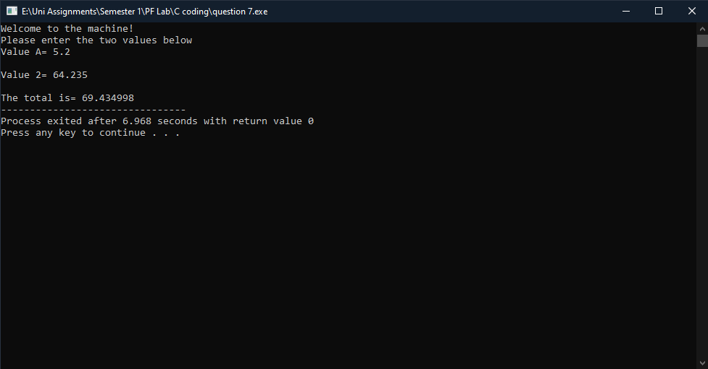

**Answer 8)**

|  |  |
| --- | --- |
| ***Name of Data Types*** | ***Size(Bytes)*** |
| Int | At least 2, usually 4 |
| Float | 4 |
| Double | 8 |
| char | 1 |

**Answer 9)**

Source Code:

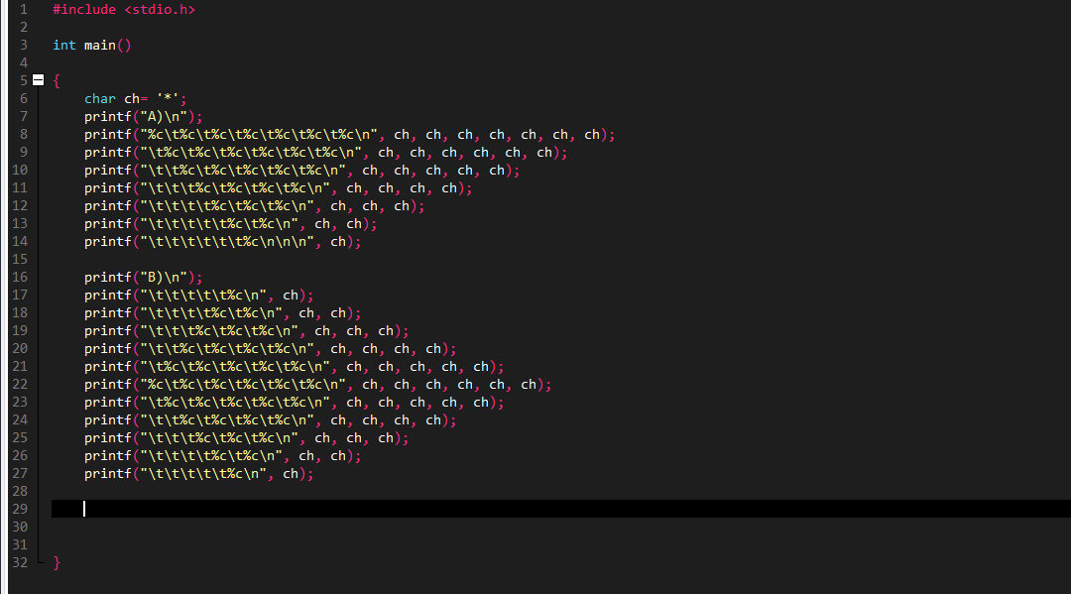

Output:

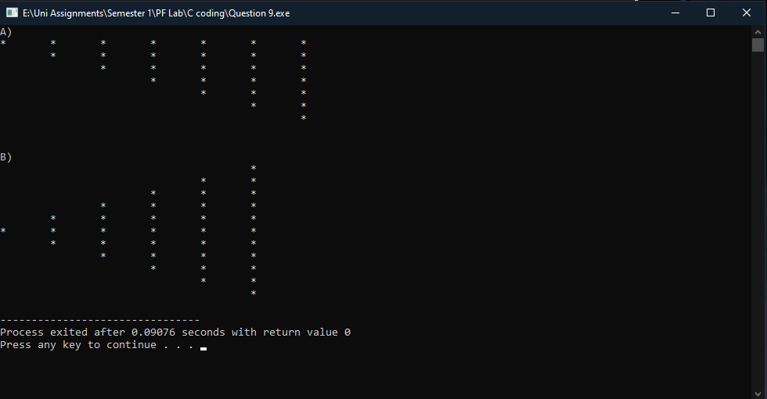

The following assignment was created and compiled by Muhammad Hussain Javed

Roll number: 21K-3584